**MODULE: 9**

**ReactJs Intro**

1. What is React Js?

**Ans.**React JS is an open-source JavaScript library used for building user interfaces or UI components. It was developed by Facebook and is maintained by a community of developers. React makes it easier to build large-scale web applications by using a component-based approach to building UIs.

2. What is NPM in React Js?

**Ans.** NPM (Node Package Manager) is a package manager for JavaScript that allows developers to easily share and reuse code. It is used to install, manage and update the packages and dependencies required by a React project.

3. What is the Role of Node Js in React Js?

**Ans.** Node.js is a JavaScript runtime that allows developers to run JavaScript on the server-side. In a React project, Node.js is used to set up the development environment, run the development server, and perform various tasks such as building and deploying the application.

4. What is CLI command In React Js?

**Ans.** CLI (Command Line Interface) is a tool that allows developers to interact with their React projects from the command line. The CLI provides various commands for creating new projects, starting a development server, building the application, and more.

5. What are Components in React Js?

**Ans.** Components are the building blocks of a React application. They are used to encapsulate UI elements and functionality into reusable and modular pieces. Components can be combined to create complex UIs, and they can also be nested inside other components.

EX.

Class Component

class Car extends React. Component {  
 render () {  
 return <h2>Hi, I am a Class Component</h2>;  
 }  
}

Function Component

function Car () {  
 return <h2>Hi, I am a Function</h2>;  
}

6. What are Header and Content Components in React Js?

**Ans.** Header and Content are examples of components in React. The Header component might contain a navigation menu, logo, and other elements that appear at the top of the page. The Content component might contain the main content of the page, such as a list of items, a form, or other UI elements.

Example:

import React from "react";

import Header from "./Header";

**function** App() {

**return**

// Using the newly created Header

// component in this main component

<Header/>

);

}

export **default** App;

7. How to install React Js on Windows, Linux Operating System? How to Install NPM and How to check the version of NPM?

**Ans.** To install React and NPM on Windows or Linux, follow these steps:

1. Install Node.js on your system (https://nodejs.org/en/download/)

2. Open a command prompt or terminal window

3. Type the following command to install React: `npm install -g create-react-app`

4. To check the version of NPM, type `npm -v` in the terminal window

8. How to check the version of React Js?

**Ans.** To check the version of React installed in your project, open the terminal or command prompt and navigate to the project directory. Then type the following command: `npm list react`. This will display the version of React installed in your project.

9. How to change components in React Js?

**Ans.** To change the components in a React project, you need to modify the component code. This can be done using any text editor or integrated development environment (IDE) such as Visual Studio Code or WebStorm. Once you have made the necessary changes to the component code, save the file and the changes will be reflected in your application.

Example:

Ex.

import React,{useState} from 'react'

import Img from './Img'

function State_func() {

const[number,setNumber]=useState(1)

const[data,setDate]=useState({

carName:"",

year:"",

isImage:true

}

)

return (

<div className='container p-5 mt-5 '>

<button onClick={()=>setNumber(number+1)}>+</button>

<h1>{number}</h1>

<button onClick={()=>setNumber(number-1)}>-</button>

<hr />

<button id='new12' onClick={()=>setDate({...data,isImage:!data.isImage})}>Show-Hide</button>

{

data.isImage? <Img/> :null

}

<hr />

<h1>CarName:GT Mustang{data.carName}</h1><br />

<h1>Year:2012{data.carName}</h1>

</div>

)

}

export default State_func

10. How to Create a List View in React Js?

**Ans.** To create a list view in React, you can use the built-in map function to iterate over an array of data and generate a list of components. Here's an example:

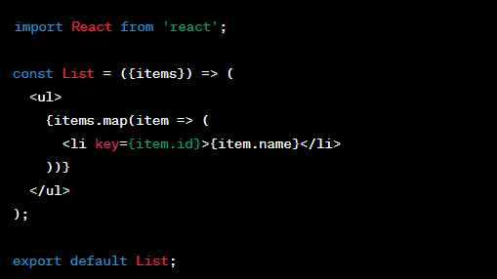

11. Create Increment decrement state change by button click?

**Ans:** import React, { useState } from 'react';

const Counter = () => {

const [count, setCount] = useState(0);

const handleIncrement = () => {

setCount(count + 1);

};

const handleDecrement = () => {

setCount(count - 1);

};

return (

<div>

<h1>Counter</h1>

<p>{count}</p>

<button onClick={handleIncrement}>Increment</button>

<button onClick={handleDecrement}>Decrement</button>

</div>

);

};

export default Counter;